**Document 1 Artificial Intelligence**

**Catherine Campbell x14428818**

Since the 1970’s computer chess has been available to the public, the use of search algorithm to allow the computer to place against a human has only gotten better with years. The 3 strategies that I will be discussing in this research paper are Depth-First Search, Best-First Search and Parrell Search. Each of these have been used in developing solutions for chess, some are still in use while others have been disused and better strategies have been developed.

**Depth-First Search**

This is an algorithm that traverses search trees using a depth ward motion. When it hits a dead end in any iteration, the algorithm uses stacks to remember to go to the next vertex to start a new search. This is achieved by the examination of the child nodes before siblings, this is implemented with recursion. This only needs one path to leaf to be kept in memory and this grows in proportion with the search depth, this means it only needs moderate memory requirements. We see this take place in the diagram below.

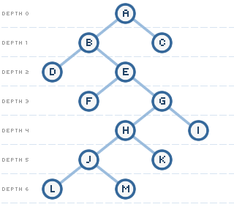 (Anon., n.d.)

The depth – limited search is the most used algorithm for creating computer chess, Alpha-Beta and Minimax are more examples of this search.

**Minimax**

This algorithm is used to determine the score in a zero-sum after, the game has progressed and evaluates the best play using a function. In relation to chess this means that minimax is used to minimize the chance of the worst-case potential loss; the algorithm takes into consideration the opponent's responses to its moves and chooses the one that will cause the least amount of damage to the computers chess set, giving it a large as possible pay off.

**Best- First Search**

This is another algorithm that is used to create chess games, it is a state space search. It traverses nodes of the tree-like data structure, using a breadth-first manner.  Instead of using a FIFO breadth-first, to expand the first level of nodes that show promise it uses priority queues method. It turns the the uninformed searches into informed searches, which makes the memory requirement and the space complexity proportional to the number of nodes used at the deepest levels.

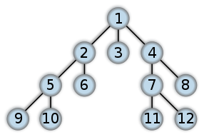 (Anon., n.d.)

We can see this in the diagram above it, it starts on node 1 and moves down the lowest level till all the possible searches have been found and the eliminated till the best possible choice is shown at the bottom.

Some of the Best- First Algorithms are A, SSS and Monte-Carlo Tree Search. In regard to using these algorithms for chess, the SSS algorithm has not been used since a conference in 1996 where it was declared dead, while the Monte-Carlo Tree Search has yet to be used to programme a chess game. The SSS algorithm was declared dead because of the problems with the algorithm, it is a hard algorithm to comprehend compare to others out there such as the Alpha-Beta. Another reason being that the SSS algorithm grows exponentially with the depth of the search tree because of its structure using OPEN list, this has brought the conclusion by many that it is un-useful in real game playing programs such as chess.